This guide has been designed to be read in conjunction with the Corporate Sponsorship Program Application Form. If
you have further questions after reading this guide, please email sponsorship@stanwell.com or call (07) 4930 3634 (Northern) or (07) 4160 9165 (South Burnett).

About Stanwell
We own and operate a portfolio of energy generation assets in Queensland. This includes two of the youngest and most efficient coal-fired power stations in Australia – Stanwell Power Station near Rockhampton and Tarong North Power Station in the South Burnett.
We are proud to generate the energy that powers Queensland lives and businesses.
We believe in affordable, reliable and clean energy and that’s why we are exploring new ways of producing electricity that enhances lives and protects the environment.

With more than 1000 employees and gas and coal-fired plant located across the state, Stanwell is well placed to provide efficient and competitive power to Queenslanders well into the future.

Our asset map
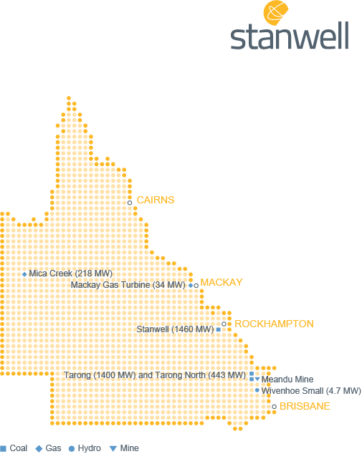
About the Corporate Sponsorship Program

Stanwell is committed to supporting activities that make a genuine ‘quality of life’ contribution to the
communities that host our assets in the South Burnett, Rockhampton and Mount Isa regions.

The activities we support will generally be events or projects that are short to medium-term in nature.
If your project could be described as a partnership (i.e. ongoing association with Stanwell and
accruing community benefits), consider applying to one of Stanwell’s community fund. See the website to find out more about these programs.

Eligibility

To be eligible for funding through Stanwell’s Corporate Sponsorship Program, you must demonstrate
that your activity meets a set of minimum criteria. This includes elements such as the activity:
  - being relevant to a specific region in which Stanwell operates (see map above)
  - having broad appeal to people within that region
  - not endorsing a private sector or political organisation, or a particular brand or product
  - not requiring a commitment beyond three years at the time of application
  - not solely benefitting an individual
  - being delivered by a capable organisation.

Preparing your application

Section 1: Applicant details
Please note all correspondence regarding the application will be sent to the contact details you supply in this section. Our preference for communication is email so, if possible, please provide an email
address that is regularly monitored.

Applications must come from a registered organisation. Applications from individuals will not be considered under this program.

Section 2: Activity overview
This is your opportunity to market the activity for which you are seeking sponsorship. Think about what makes your activity special and the relationship between the event and Stanwell.

In this section, you also need to provide all the basic information about the activity – location, date/s,
time/s and, critically, who will receive any funds raised through the activity.

Section 3: Organisation overview
In this section you are required to describe your organisation and what it does.
If your activity will benefit one of Stanwell’s host communities but your organisation isn’t local, or if
your activity will also benefit other region/s, it is important that you explain how much of your activity is
directly relevant to a Stanwell host community.

If other organisations will be helping deliver the activity, tell us in this section.

Section 4: Sponsorship details
Tell us the value of the sponsorship you are seeking, either as a dollar figure or range, or in terms of
goods/in-kind contributions. If you feel it will improve the strength of your overall application, attach
quote/s for items or services.

In this section, detail any other sponsors you have already secured for the activity or who are major
sponsors of your organisation.

If there is flexibility in the amount you are asking for (for example, Gold, Silver, Bronze levels of
sponsorship) provide details of other options Stanwell could consider.

Please note that any ongoing costs associated with the activity beyond those specified in your
application will not be funded by Stanwell.

Section 5: Community benefits
Explain who will benefit from the activity and how (e.g. students from Smith State School grades 2-6
accessing specialist music tuition). If the activity will bring a range of people in a community together,
tell us how often and for what purpose.

Section 6: Benefits to Stanwell
Stanwell will usually want to see the Stanwell logo (generally the local Stanwell asset name)
associated with the activity, but there are other ways to acknowledge Stanwell’s support in addition to
or instead of branding. Examples of benefits include (but are not limited to):
- Advertising placements
- Speaking opportunities
- Media exposure
- Attendance at/tickets to the activity or related events
- Access to goods and services related to the activity
- Right to use associated footage/photographs.

Consider what will work best for your activity that aligns with Stanwell’s brand and business.

Section 7: Declaration
The representative signing this section should be the most senior person in your organisation and/or
the person overseeing the activity.

Application checklist

Before you send in your application, confirm that you have:
- correctly completed your application:
- All seven sections of the application form have been completed.
- Your contact details are correct.
- The declaration has been signed by the appropriate representatives/s.
- attached:
- Copies of associated quote/s, if applicable.

When to apply

Applications can be submitted at any time, but it is advisable that you allow sufficient lead time to
ensure your activity receives due consideration and for Stanwell to realise the value of benefits being
offered. A minimum of eight weeks before the funds are required is recommended.

Where to apply

Email sponsorship@stanwell.com

For activities related to the South Burnett:

Community Relations Coordinator
Tarong Power Station
PO Box 15
NANANGO QLD 4615

For activities related to communities in and surrounding Rockhampton and Mount Isa:

Community Relations Advisor
Community and Stakeholder Engagement
GPO Box 800
BRISBANE QLD 4001

The process

We aim to provide a final decision in writing (email or letter) within four weeks of receipt of your
application. If you have provided an email address, you will also receive an email acknowledging
receipt of your application to signal that the evaluation process is underway.

Note that successful applicants may be required to sign an agreement with Stanwell that clearly
outlines the conditions attached to the funding. Regardless of the amount, we will document our
expectations in relation to benefits and explain the payment process in a letter/email.

Disclaimer

Stanwell’s Corporate Sponsorship Program has a fixed budget for each financial year that must be
balanced across multiple communities and activity types. This means that some applications will not
be successful, regardless of their quality and/or suitability.

If your application is unsuccessful on one occasion, you can generally submit a new application for the same activity the following financial year. Alternatively, it may qualify for consideration under another Stanwell funding program, in which case you will be notified.

